On the Attrition dataset, Wilcoxon, Friedman and 2-sample Paired T-test tests cannot be applied, as there are no columns that indicate any change of conditions(No Paired sample)

* Pearson Test

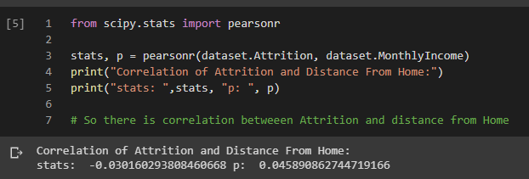

* Mann-Whitney Test

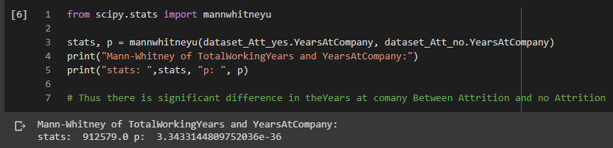

* Kruskal Wallis Test

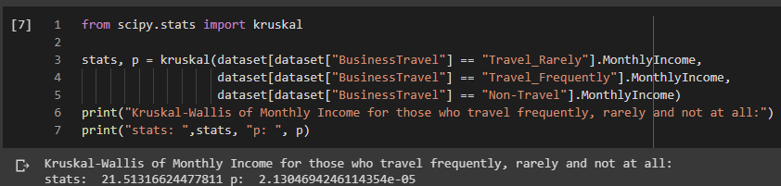

* Chi-Square Test

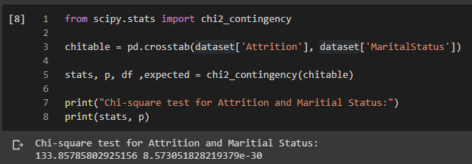

* 1 Sample T-Test

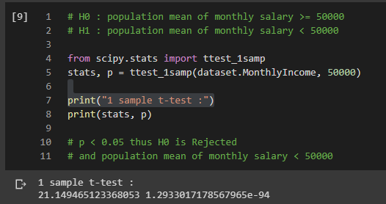

* 2 Sample Separate T-Test

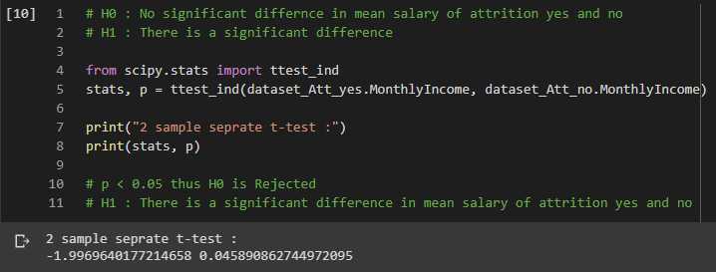

~By Abhijeet Mankani

AI-ML Batch1 July 2020

Link to Notebook of Code:

<https://colab.research.google.com/drive/1-tIVByyhaj94wBnnMOTlKQ-YV_IqTtUD?usp=sharing>